
Year 12 Human Biology
Unit 3: Endocrine and Nervous System (5%)

TASK 2
TYPE: Test
CONTENT: Endocrine and Nervous System

Time: 60 mins

Multiple Choice: 15 marks
Short Answer: 25 marks
Extended Answer: 20 marks
TOTAL 60 MARKS

Do not turn page until instructed to do so
Section A: Multiple Choice (15 Marks)
Answer all questions by placing an X through the most correct answer on the multiple choice answer sheet.

3. Which of the following is FALSE about the comparison between nervous and hormonal actions of the body?

 | Nervous Action | Hormonal action
a) | Impulse electro chemical | Impulse chemical
b) | Messenger passed along nerve fibres. | Messenger passed by blood stream
c) | Response slow and lasting | response swift and short
d) | Not concerned with growth and development | Concerned with growth and development

6. Which one of the following is correct?
 | Structure | Sympathetic  Activity | Parasympathetic Activity
a) | Urinary bladder | Relaxation | Contraction
b) | Salivary glands | Increased secretion | Reduced secretion
c) | Liver | Increased glucose uptake | Increased release of glucose
d) | Bronchioles of the lung | Constriction | Relaxation

7. Voluntary muscle movement is controlled by:

- an upper motor neuron in the brainstem and a lower motor neuron in the spinal cord.
- an upper motor neuron in the cerebrum and a lower motor neuron in the spinal cord.
- an upper motor neuron in the cerebrum and a lower motor neuron in the dorsal root ganglion.
- an upper motor neuron in the spinal cord and a lower motor neuron in the skeletal muscle

8. Injury to the hypothalamus may result in all of the following EXCEPT:

- a loss of temperature control.
- a production of excessive quantities of urine.
- loss of awareness of body position.
- a disrupted menstrual cycle.

9. Which of the following is NOT a function of the cerebrospinal fluid?

- Transfer of neural messages from one part of the brain to another.
- Aid removal of metabolic wastes and supply of nutrients to nerve tissue.
- Suspension of the brain in fluid to reduce pressure on particular points.
- Protection of the central nervous system from mechanical damage.

10. Which statement about nerve fibres is correct?

- Fibres that have a larger diameter will conduct impulses slower than those with a smaller diameter.
- Myelinated fibres conduct impulses slower than unmyelinated nerve impulses.
- Nodes of Ranvier increase the speed of nerve impulse transmission.
- All myelinated nerve impulses end on skeletal muscles.

11. The spinal cord has white matter:

- inside, grey matter outside.
- outside, grey matter inside and a ventral motor root.
- outside, grey matter inside and a dorsal motor root.
- inside, grey matter outside and a ventral motor root.

12. The somatic division belongs to which component of the peripheral nervous system?

- Afferent
- Autonomic
- Efferent
- Parasympathetic

13. Which of the following is correct?

- Afferent division carries information into the CNS
- Efferent division carries information away from the CNS
- The autonomic division is responsible for preparing the body for strenuous physical activity
- All of the above

14. If the sympathetic nerve to the heart was cut, the heart rate would be expected to:

- increase.
- decrease.
- stay the same.
- increase then decrease.

15. Looking at the picture below, the synapse is labelled:

- P
- Q
- R
- S

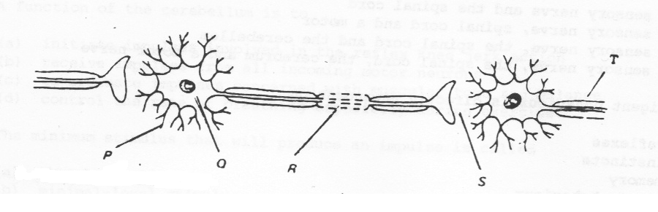

END OF SECTION A

Year 12 Human Biology
Unit 3: Endocrine and Nervous System (5%)

Name _____________________________
Teacher_____________________________

TASK 2
TYPE: Test
CONTENT: Endocrine and Nervous System
TOTAL: /60 MARKS

Section A: Multiple Choice answer grid 15 marks
For each question, shade the box to indicate your answer. Use only a blue or black pen to shade the boxes.
For example, if b is your answer: a b c d
If you make a mistake, place a cross through that square, then shade your new answer. Do
not erase or use correction fluid/tape.
X
For example, if b is a mistake and d is your answer: a b c d
If you then want to use your first answer b, cross out d and then circle b.
X
X
a b c d
Marks will not be deducted for incorrect answers. No marks will be given if more than one answer is completed for any question.
11 | a b c d
12 | a b c d
13 | a b c d
14 | a b c d
15 | a b c d

1 | a b c d
2 | a b c d
3 | a b c d
4 | a b c d
5 | a b c d

6 | a b c d
7 | a b c d
8 | a b c d
9 | a b c d
10 | a b c d

Section B: Short Answer (25 Marks)
Answer all questions in the spaces provided.

Question 17 (4 Marks)

A boy was asked to speak, on behalf of the student body, at his year 12 Graduation ceremony. Prior to his speech, he felt extremely nervous.

- Name the specific part of his nervous system would have contributed to his condition.

(1 mark)

____________________________________________________________________________

- Name the hormone(s) which would have been involved in this process.

(1 mark)

___________________________________________________________________________

- Name where this hormone(s) are released from. (1 mark)
____________________________________________________________________________

- Compare the actions of nerves and hormones in regard to the specificity of their actions.

(1 mark)
___________________________________________________________________________

___________________________________________________________________________

Question 18 (3 marks)
The diagram below represents the transmission of a nerve impulse down an axon.
A B C

A B C

A B C

Name the different bands labelled A, B, and C and outline what they signify in terms of a nerve impulse. (3 marks)
A ____________________________________________________________________________

______________________________________________________________________________

B ____________________________________________________________________________

______________________________________________________________________________

C ____________________________________________________________________________

______________________________________________________________________________

Question 19 (4 marks)
Picture A

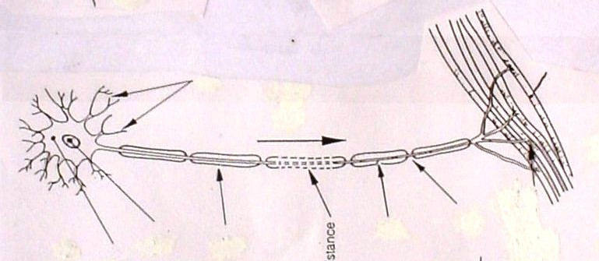

- Classify the neuron in picture A according to its structure and function. (2 marks)
Structure
______________________________________________________________________________

Function
______________________________________________________________________________

- This type of neuron can transmit an electrical impulse up to 140 metres/second. Explain the reasons why the impulse is able to travel at this speed. (2 marks)

______________________________________________________________________________

______________________________________________________________________________

______________________________________________________________________________

______________________________________________________________________________

______________________________________________________________________________

END OF SECTION B

Section C: Extended Answer (20 Marks)
Answer all parts of ALL questions on the lines provided.
Question 22

The Chemical Weapons Convention was agreed upon in 1997 which prevents the use of chemical weapons to deliberately harm another person. Today, 192 countries are under this treaty which is now international law.

On March 4 2019, former Russian spy Sergei Skripal, his daughter Yulia were exposed to Novichok (a nerve agent) in England. This nerve agent acts to inhibit the enzyme which breaks down neurotransmitters at synapses in the cental and peripheral nervous systems.

- Describe what happens when a neurotransmitter is not removed from the synapse. (3 marks)

- Using the somatic nervous system as an example, describe how a nerve impulse travels across a synapse to the effector. (5 marks)

- Action potentials are described as ‘all or none responses’. However, it is possible for you to detect the difference between a sheet of paper and a brick being dropped on your foot. Explain why. (3 marks)

______________________________________________________________________________

______________________________________________________________________________

______________________________________________________________________________

______________________________________________________________________________

______________________________________________________________________________

______________________________________________________________________________
______________________________________________________________________________

______________________________________________________________________________

______________________________________________________________________________

______________________________________________________________________________

______________________________________________________________________________

______________________________________________________________________________
______________________________________________________________________________

______________________________________________________________________________

______________________________________________________________________________
______________________________________________________________________________

______________________________________________________________________________

______________________________________________________________________________
______________________________________________________________________________

______________________________________________________________________________

______________________________________________________________________________
______________________________________________________________________________

______________________________________________________________________________

______________________________________________________________________________
______________________________________________________________________________

______________________________________________________________________________

______________________________________________________________________________
______________________________________________________________________________

______________________________________________________________________________

______________________________________________________________________________
______________________________________________________________________________

______________________________________________________________________________

______________________________________________________________________________
______________________________________________________________________________

______________________________________________________________________________

______________________________________________________________________________
______________________________________________________________________________

______________________________________________________________________________

______________________________________________________________________________
______________________________________________________________________________

______________________________________________________________________________

______________________________________________________________________________
______________________________________________________________________________

______________________________________________________________________________

______________________________________________________________________________
______________________________________________________________________________

______________________________________________________________________________

______________________________________________________________________________
______________________________________________________________________________

______________________________________________________________________________

______________________________________________________________________________

______________________________________________________________________________
______________________________________________________________________________

______________________________________________________________________________

______________________________________________________________________________

______________________________________________________________________________
______________________________________________________________________________

